Measurement of Aerosol

Main principle behind aerosol measurement – Beer Lambert law – light suffers attenuation when passes through material due to scattering by the particles present in the medium

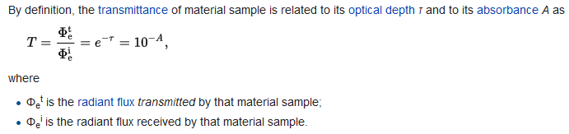

The **Beer–Lambert law** states that, for *N* attenuating species in the material sample,

T = e − ∑ i = 1 N σ i ∫ 0 ℓ n i ( z ) d z = 10 − ∑ i = 1 N ε i ∫ 0 ℓ c i ( z ) d z , {\displaystyle T=e^{-\sum _{i=1}^{N}\sigma _{i}\int _{0}^{\ell }n_{i}(z)\mathrm {d} z}=10^{-\sum _{i=1}^{N}\varepsilon _{i}\int _{0}^{\ell }c_{i}(z)\mathrm {d} z

• *σi* is the [attenuation cross section](https://en.wikipedia.org/wiki/Cross_section_%28physics%29) of the attenuating species *i* in the material sample;

• *ni* is the [number density](https://en.wikipedia.org/wiki/Number_density) of the attenuating species *i* in the material sample;

Attenuation due to Rayleigh scatter, and absorption by ozone, and gaseous pollutants is estimated and removed to isolate the aerosol optical depth (AOD).

If optical depth

less than 0.5 – clear sky

more than 1 – hazy conditions

2 or 3 – high conc. Of aerosols

Technique used by One instrument called SAGE

SAGE instruments use solar occultation measurement technique to determine chemical concentrations in the atmosphere. Solar occultation measurement technique measures sunlight through the atmosphere and ratios that measurement with a sunlight measurement without [atmospheric](https://en.wikipedia.org/wiki/Atmospheric) [attenuation](https://en.wikipedia.org/wiki/Attenuation). This is achieved by observing sunrises and sunsets during a satellite orbit. Physically, the SAGE instruments measure ultraviolet/visible energy and this is converted via [algorithms](https://en.wikipedia.org/wiki/Algorithms) to determine chemical [concentrations](https://en.wikipedia.org/wiki/Concentrations). SAGE data has been used to study the atmospheres aerosols, ozone, water vapor, and other trace gases.

The SAGE II instrument measures sunlight through the limb of the Earth's atmosphere (Fig) in seven spectral wavelengths (from 0.385-1.02 micrometers). The measured sunlight, which was scattered and absorbed by trace gases and aerosols, is converted into vertical profiles of ozone, water vapor, nitrogen dioxide and aerosol concentrations.

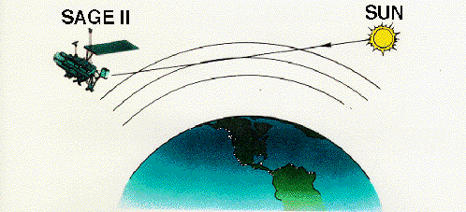

**AVHRR – 5 cameras** (one each for 600nm, 900 nm, 3500nm & 2 for 11000nm). AVHRR measures the intensity of sunlight as it reflects off aerosols using the dark ocean as background.

Satellite studied for this purpose – NENO_AM

**NENO_AM** ( A satellite supported by ISRO )

NENO_AM - Made by Space Flight laboratory, University of Toronto, Institute for Aerospace studies

|  |  |
| --- | --- |
| Type | autonomous |
| Orbit | Sun synchronous |
| Altitude | 600-800 km |
| Mass | 16.1 kg |
| Volume | 20*20*40 cm3 |
| Solar array (pre deployed) | 62*58 cm2 |
| Voltaic cells | 70 |
| Power | 80W |
| Communication | S band |
| Payload (multispectral imager) | |
| Focal length | 150 mm |
| F no. | 1/ 2.8 |
| Resolution | 200 m of ground |
| Wavelength range | 400-1000 nm |
| FOV | + - 4.46 deg. |
| Pixel density of each image on each polarisation | 2444 * 888 pixels |

Imager divides light into blue, red & near infrared spectral bands, “p-s” polarizing beam splitter which generates 2 identical images at 2 different polarizations ( 0 deg. & 90 deg.)

Requirements on control subsystem

Imager should continuously point at target of interest. Antenna should also continuously point towards ground station to achieve high speed image downlink. When not in observing or downloading mode, solar array should point to sun. 2 observations & 2 downlink per day.

For imaging there should be full 3-axis control & 1 arc minute pointing stability(so it has used star tracker).

Requirements on OBC

1. There are 3 IOBCs and each IOBC command individual imager to take image.
2. Transfer observational data into onboard Flash.
3. High speed transmission of payload data to the ground

Some other interesting techniques on NENO-AM

1. It has used GNB concept - Generic Nanosatellite Bus (GNB) concept, where a multipurpose and adaptable satellite bus is designed to work with a wide range of payloads with little or no modification.
2. To minimize weight, Magnesium alloys were used which were plated with high phosphorus electroless nickel to prevent oxidation.
3. Solar array shadows the bus and helps to keep it cool which is imp. To reduce the noise on payload.

[**What are the benefits of having multiple camera angles?**](https://eosweb.larc.nasa.gov/faq-page/misr-faq)

Measuring the reflectance of a target from different directions is really useful because geophysical media (the atmosphere, including the clouds and aerosols, the ocean, and terrestrial surfaces such as soil, vegetation and snow or ice) reflect solar light differently in different directions. In fact, the variations between the reflectances acquired from a variety of observation angles can be interpreted (with appropriate models) to document the properties of the target, just as the more familiar spectral differences are exploited to document its chemical composition.

Most imaging space-borne instruments acquire measurements for each location on Earth from a single direction at a time, usually within the limited range of (across-track) observation zenith angles allowed by the scanner or push-broom design of the sensor. The accumulation of multiangular observations with such instruments necessitates revisiting the site over rather long periods of time, from multiple days to a few weeks or more. By incorporating nine separate cameras oriented at various angles along the track of the platform through constellation we will be capable of acquiring multiple observations of the same site from a wide variety of zenith angles in a matter of a few minutes. This greatly facilitates the interpretation of the measurements and significantly improves the accuracy of the retrieved information.

Specifically, using its multi-angular and multi-spectral capability we can

1. better distinguish between objects and surfaces than would be possible on the basis of spectral variations alone;
2. exhibit an enhanced sensitivity to aerosols and thin cirrus clouds, both of which are ubiquitous and usually hard to detect, especially at large observation zenith angles and/or over bright backgrounds;
3. provide a three-dimensional (stereoscopic) view of clouds that allows users to estimate their height;
4. make it possible to use clouds as tracers of winds aloft due to the time lapse (about 7 minutes) between the most forward and the most backward views;
5. yield at once measurements that accentuate or minimize the effect of sun glint over the ocean and other water surfaces, thereby enabling observations even when traditional sensors are hampered by the very high reflectance of these surfaces, and
6. permit users to much more accurately estimate the hemispherical albedo of the target, which is thus calculated on the basis of nine different values instead of only one